**Year 10 Science – Rapid Reactions Pre-test**

Name: ___________________________________

**How much do you know and understand? Answer each question to the best of your ability.**

1. What are the three particles that make up an atom?
   1. Protons, neutrons, and isotopes
   2. Neutrons, isotopes, and electrons
   3. Positives, negatives, and electrons
   4. Protons, neutrons, and electrons
2. The space surrounding the nucleus of an atom contains___________

a. protons

b. electrons

c. neutrons

d. isotopes

1. Protons are:

a. positively charged

b. negatively charged

c. neutral

d. always equal to the number of neutrons in an atom

1. Label the parts of this atom:

|  |  |  |  |
| --- | --- | --- | --- |
| electron | proton | neutron | nucleus |

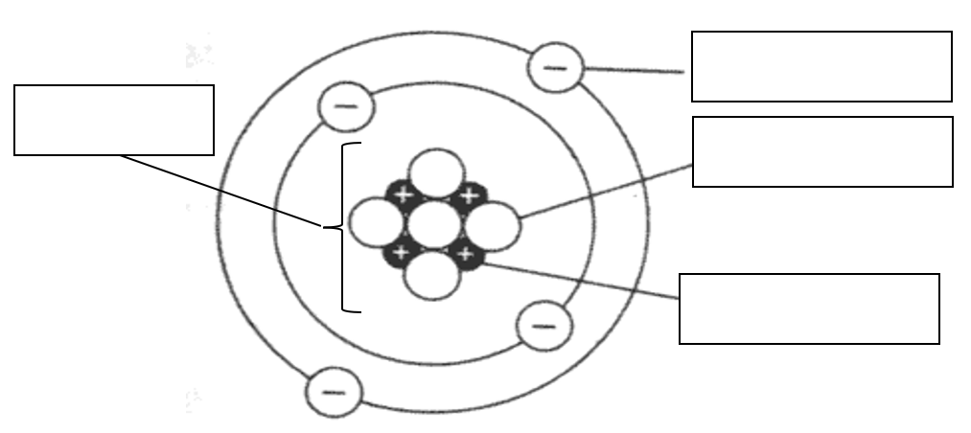

1. Match the correct term with each definition

|  |  |  |
| --- | --- | --- |
| **Term** |  | **Definition** |
| Atomic Number |  | The smallest particles of an element that are the building blocks of matter. |
| Atom |  | The number of protons and neutrons in an atom. |
| Element |  | The number of protons in an atom |
| Mass Number |  | A pure substance consisting of only one type of atom. |

1. Complete the missing space(s) in each row of the following table:

|  |  |  |  |  |  |
| --- | --- | --- | --- | --- | --- |
| **Isotope** | **Atomic Number** | **Mass Number** | **Protons** | **Electrons** | **Neutrons** |
| Lithium - 7 | 3 | 7 |  | 3 | 4 |
| Carbon - 13 |  | 13 | 6 |  | 7 |
| Boron - 10 | 5 |  | 5 | 5 | 5 |
| Helium - 4 | 2 | 4 | 2 | 2 |  |

1. The production of magnesium oxide gives a bright white colour. This comes from the reaction between magnesium and oxygen.
   1. Complete the table to show the reactants and products for this reaction.

|  |  |
| --- | --- |
| **Reactants** | **Products** |
|  |  |

* 1. Write a word equation for this reaction
  2. Write a balanced chemical equation for this reaction